**Lesson3 APP6:**

**Detach an EBS Volume**

**Selecting the EBS volume you want to detach:**

* Choose the bucket

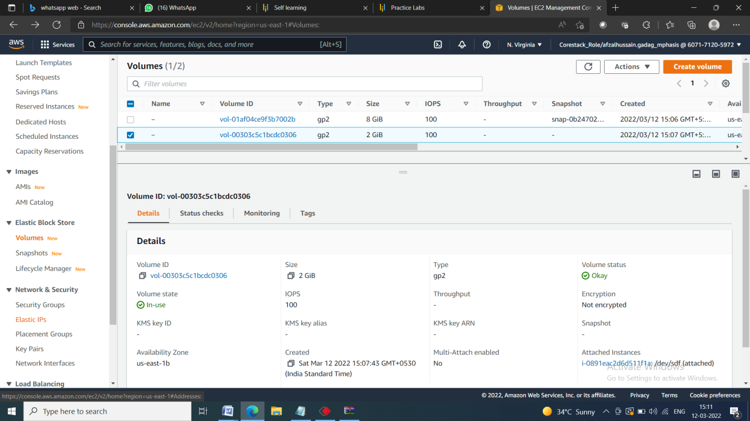

* Select Detach Volume option

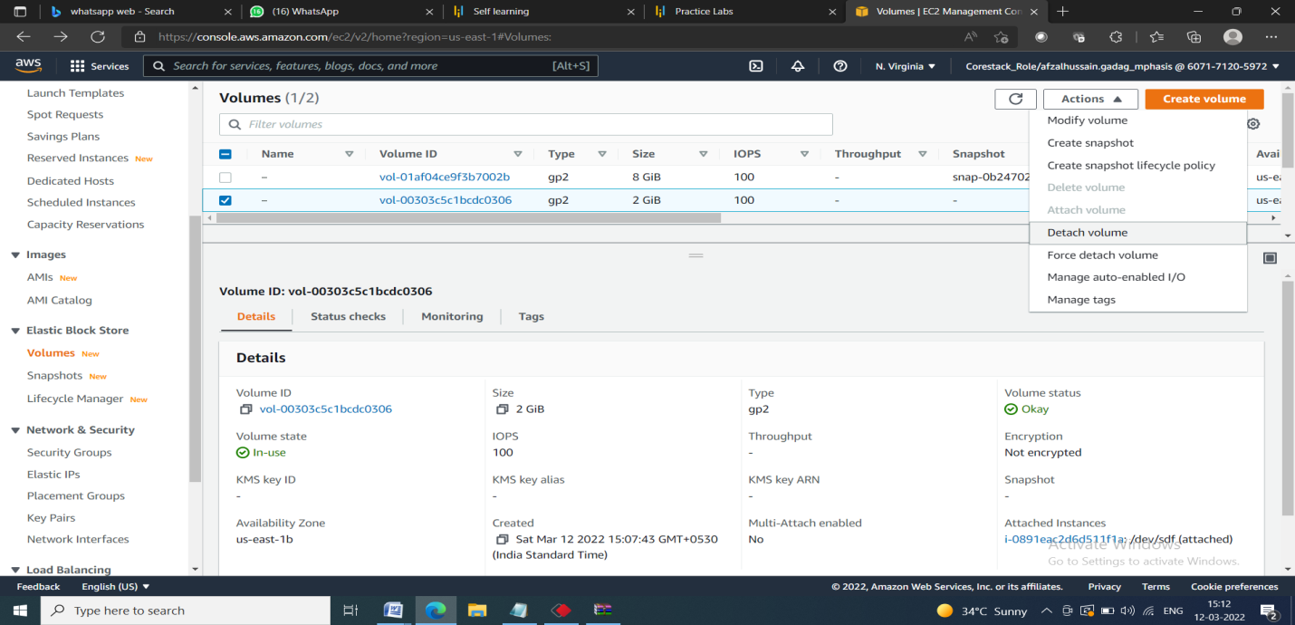

**Detaching the volume:**

* Select *Yes* once the confirmation pop-up appears

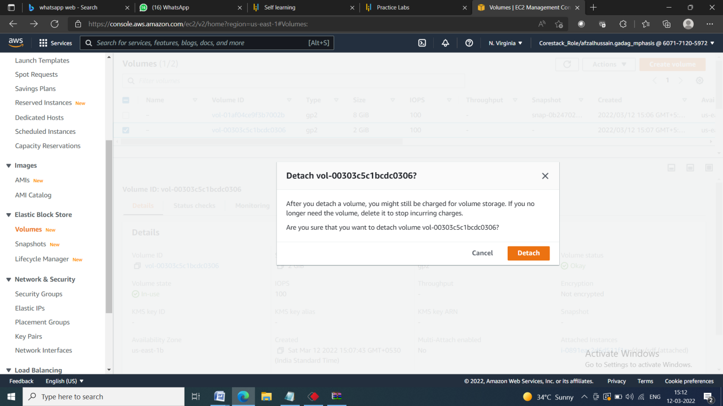

* Once detached, the volume will be labelled as Available

